ONEWAY SA BY Gender1
/STATISTICS DESCRIPTIVES HOMOGENEITY WELCH
/PLOT MEANS
/MISSING ANALYSIS.

Oneway

Notes
Output Created |  | 05-May-2019 23:09:00
Comments
Input | Active Dataset | DataSet0
Input | Filter | <none>
Input | Weight | <none>
Input | Split File | <none>
Input | N of Rows in Working Data File | 30
Missing Value Handling | Definition of Missing | User-defined missing values are treated as missing.
Missing Value Handling | Cases Used | Statistics for each analysis are based on cases with no missing data for any variable in the analysis.
Syntax |  | ONEWAY SA BY Gender1  /STATISTICS DESCRIPTIVES HOMOGENEITY WELCH  /PLOT MEANS  /MISSING ANALYSIS.
Resources | Processor Time | 00 00:00:00.172
Resources | Elapsed Time | 00 00:00:00.169

[DataSet0]

Descriptives
 | N | Mean | Std. Deviation | Std. Error | 95% Confidence Interval for Mean
 |  |  |  |  | Lower Bound | Upper Bound
Female | 6 | 45.0000 | 17.46997 | 7.13209 | 26.6664 | 63.3336
Male | 24 | 22.0000 | 13.28942 | 2.71269 | 16.3884 | 27.6116
Total | 30 | 26.6000 | 16.74062 | 3.05640 | 20.3490 | 32.8510

Descriptives
 | Minimum | Maximum
Female | 23.00 | 67.00
Male | 5.00 | 60.00
Total | 5.00 | 67.00

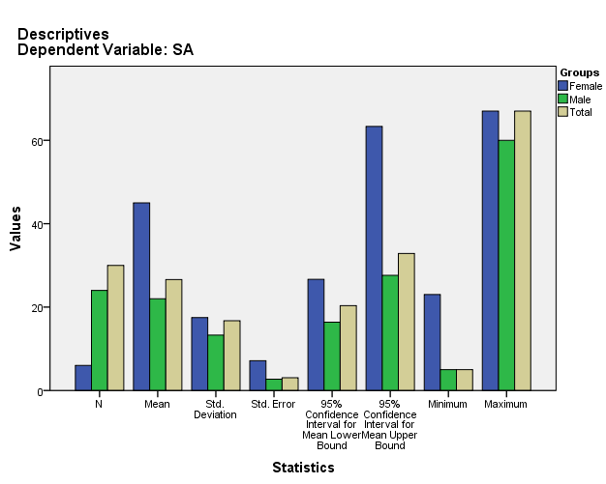

Test of Homogeneity of Variances
SA
Levene Statistic | df1 | df2 | Sig.
2.049 | 1 | 28 | .163

ANOVA
SA
 | Sum of Squares | df | Mean Square | F | Sig.
Between Groups | 2539.200 | 1 | 2539.200 | 12.723 | .001
Within Groups | 5588.000 | 28 | 199.571
Total | 8127.200 | 29

Robust Tests of Equality of Means
SA
 | Statisticª | df1 | df2 | Sig.
Welch | 9.085 | 1 | 6.522 | .021
a. Asymptotically F distributed.

Means Plots

